Rare Earth Free e-Drives Featuring Low Cost Manufacturing
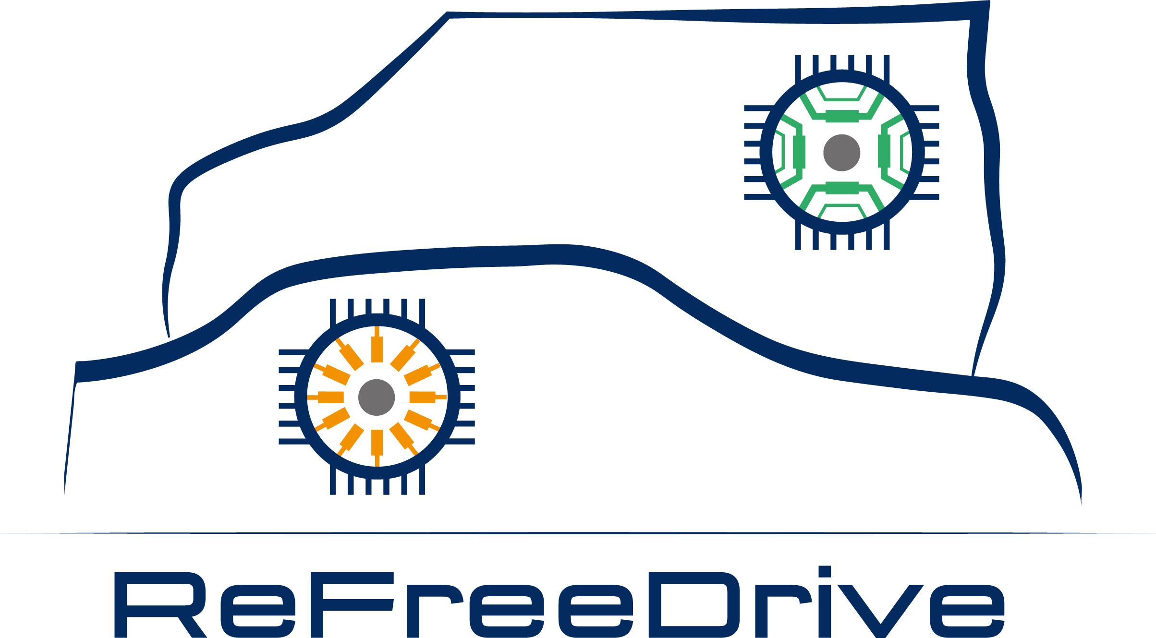
Collaborative Project
Grant Agreement Number 770143
Start date of the project: 1st October 2017, Duration: 36 months
This project has received funding from the European Union’s Horizon 2020 research and innovation programme under grant agreement No 770143
Deliverable no.: | D3.1
Title of the deliverable: | Preliminary Copper-Rotor Induction Motor Design
Contractual Date of Delivery: |  | 20 April 2018
Actual Date of Delivery: |  | 20 April 2018
Lead contractor for this deliverable: |  | Motor Design Ltd. (MDL)
Author(s): |  | Popescu, Mircea (MDL), Riviere, Nicolas (MDL)
Participant(s): |  | Villani, Marco (UAQ), Fabri, Giuseppe (UAQ)
Work package contributing to the deliverable |  | WP3
Nature: |  | Confidential
Version: |  | 3.2

Abbreviations
ATF: Automatic Transmssion Fluid
CR: Copper Rotor
CR-IM: Copper Rotor – Induction Motor
EDT: Electric Drives Technologies
EGW: Ethylene-Glycol (based) Water
EMF: ElectroMotive Force
EV: Electric Vehicle
FEA: Finite Element Analysis
ID: Inner Diameter
IM: Induction Motor
IR: Inner Rotor
KPI: Key Performance Indicator
MTPA: Maximum Torque Per Ampere
OD: Outer Diameter
OR: Outer Rotor
TRV: Torque per Rotor Volume
WP: Work Package

Executive Summary
The present report covers a preliminary design analysis for Copper-Rotor Induction Motors (CR-IMs) for traction systems in Electric Drive Technologies (EDT). This is one of the technical solutions investigated by ReFreeDrive project.
The overall objectives of the entire WP3 are according to the ReFreeDrive GA:
- To identify the key factors in copper alloy cage rotor Induction Motor (IM) design that lead to an increase in power/torque density and lower cost.
- To select the materials – copper alloy and electrical steels laminations - for IM high speed applications eliminating rare earth materials content and lowering costs.
- To achieve an electro-magnetic design of an IM with internal rotor (IR) fulfilling the requirements specified in WP2.
- To achieve the electro-magnetic design of an IM with outer rotor (OR) fulfilling the requirements specified in WP2. A comparison of different stator-rotor configurations will be done for evaluating the best trade-off between performance and cost.
- To design the cooling system and analyze the selected IR-IM and OR-IM topologies based.
- To ensure the mechanical design of the selected topologies (i.e., mechanical strength to centrifugal forces, etc).
In WP3, IR-IM and OR-IM configurations with cage built using die-casted or fabricated rotor technologies are proposed. When IR topology is used in combination with high rotational speed, i.e. $≥$ 15000rpm, the torque density and the specific power are increased.
Similarly, an OR topology can be used at lower rotational speed, i.e. $≤$ 15000rpm, the increase in torque density and specific power is guaranteed due to the inherent higher diameter in the motor airgap.
Deliverable D3.1 (Preliminary CR-IM Design) aims at designing proof of concept designs for IR-IM and OR-IM solutions that are scalable and ready to be used at various power and supply levels according to the EV type.
Scalability principles rely on the same radial dimensions of the stator/rotor laminations, only the winding pattern, current level is changed according to the voltage and current levels that are available.
An initial design is optimised for the higher power (200kW as in Track 1 within ReFreeDrive GA document). This will be used also for lower power (75kW as in Track 2 within ReFreeDrive GA document).
The objectives of deliverable D3.1 are according to ReFreeDrive GA document:
- Task 3.1.1, Preliminary analysis of induction motor technology: as a pre-design stage different stator slots and rotor poles configurations are considered, IR and OR topologies, windings with hairpin/flat wire are proposed, different cooling systems are modelled.
- Task 3.1.2, Selection of materials for IM applications: the active components of IM are modelled considering various electrical steel grades for stator/rotor laminations and die-cast and fabricated copper alloys for the rotor cage.
- NOTE: Due to difficulties and delays in procuring various electrical steel samples, the analysis of the CR-IM designs with different electrical steel grades will be covered in D3.2. In this report only one non-oriented, fully processed electric steel grade M235-35A is considered
The degree of fulfilment of the objectives in D3.1 is partially complete due to the delay in procuring the electrical steel samples and only Task 3.1.1 is fully complete. The Task 3.1.2 will be addressed and included in deliverable D3.2: “Electro-magnetic Copper Rotor Induction Motor Design”.
This report is divided in four main sections.
- Section 1 (Introduction), it is presented the logic of the design process and how various parameters are selected to act in concert to meet the specified requirements, including rotor and stator dimensions, number of slots / poles / bars, optimal winding pattern and materials to be used.
- Section 2 (CR-IM Electromagnetic Design) describes the first pass design with various motor configurations, when the number of poles is changed. The design analysis is based on a hybrid 2D Finite-Element Analysis (FEA) method and analytical magnetic equivalent circuit.
- Section 3 (CR-IM Mechanical Analysis) describes the dimensions and speed limits from the mechanical stress and modal analysis point of view. The analysis makes use of 2D/3D FEA models and analytical expressions.
- Section 4 (CR-IM Thermal Analysis) describes the first pass design with various motor configurations, when the cooling system comprises a stator water jacket, a rotor cooling jacket and/or an oil spray cooling system. The design analysis is based on a lumped analytical thermal network method, validated with 2D FEA method.

The preliminary design study shows that one set of stator/rotor laminations can be used with various number of poles by implementing the corresponding winding patterns. Both IR and OR topologies can be built with 36 stator slots and 50 rotor bars, with hairpin winding type. The Figure ES.1 and Figure ES.2 show the two configurations.
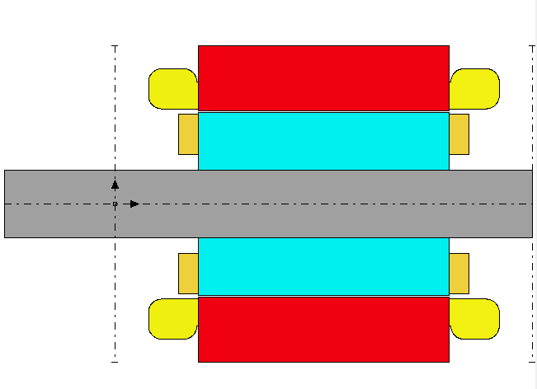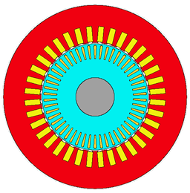

Figure ES.1 Radial and axial view of IR-IM, 36 slots / 50 bars / 2, 4 or 6 poles
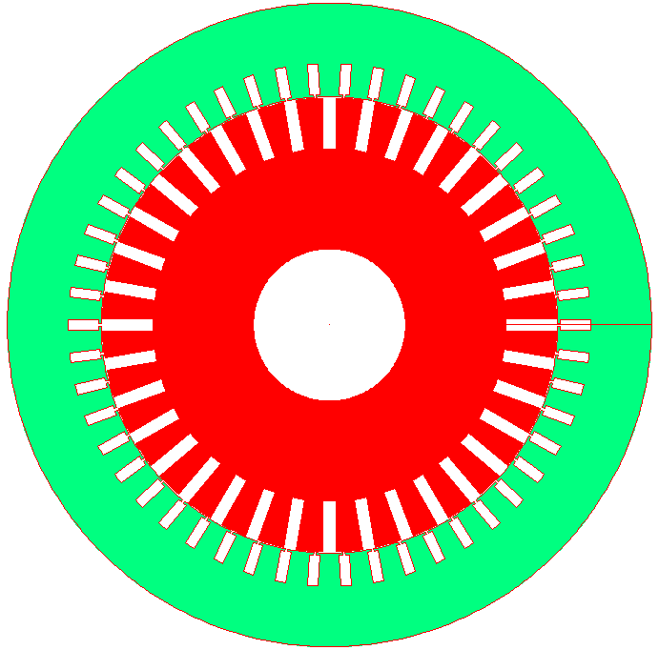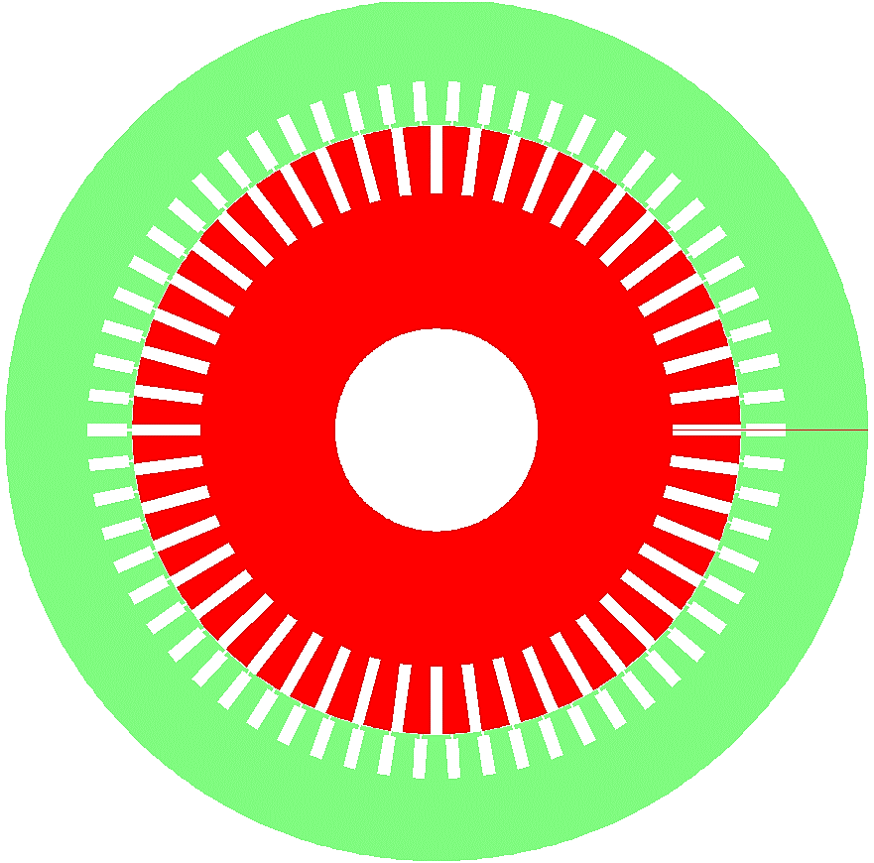

(a) 36 stator slots, 50 rotor bars (4 or 6 poles) | (b) 48 stator slots, 62 rotor bars (8 poles)
Figure ES.2 Radial view of OR-IM

The comparison between various configurations shows that 4-pole for IR topology and 6-pole for OR topology are the recommended solutions for further optimisation. The peak and KPI values for the IR-IM and OR-IM configurations are given in Table ES.1 and Table ES.2 respectively, considering just the active weights and volumes.
Table ES.1 Peak and KPI values for IR-IM
Parameter | Unit | Value
 |  | 2-pole | 4-pole | 6-pole
Specific Peak Power | kW/kg | > 5.5 | > 5.5 | > 5.5
Peak Power Density | kW/L | N/A | N/A | N/A
Specific Peak Torque | Nm/kg | 6.75 | 10.8 | 9
Peak Torque Density | Nm/L | N/A | N/A | N/A
Peak efficiency | % |  |  | > 96
Table ES.2 Peak and KPI values for the OR-IM
Parameter | Unit | Value
 |  | 4-pole | 6-pole | 8-pole
Specific Peak Power | kW/kg | > 4.0 | > 4.0 | > 3.0
Peak Power Density | kW/L | N/A | N/A | N/A
Specific Peak Torque | Nm/kg | > 8.0 | > 7.2 | > 5.0
Peak Torque Density | Nm/L | N/A | N/A | N/A
Peak efficiency | % | > 94 | > 94 | > 93
The mechanical analysis confirmed that the proposed IR and OR designs are within the maximum acceptable limits for the mechanical stress and natural frequencies that may occur.

In the thermal analysis, this report shows clearly that for IM designs, a rotor cooling system is essential. If only a stator cooling system is used, the performance of IM for EDT will be drastically reduced. The Table ES.3 shows the comparison between the three cooling systems that are analysed. Just the IR-IM solution is considered in this report for thermal analysis.
Table ES.3 Summary on thermal performances of IR-IM
Parameter | Unit | Cooling system type
 |  | Stator and Rotor jackets | Stator  jacket | Stator jacket and oil spray
Max torque | Nm | 137 | 66 | 112
Max power | kW | 134 | 85 | 88
Max efficiency | % | 95.95 | 96.00 | 96.37
Coolant | N/A | EWG 50/50 | EWG 50/50 | ATF mineral oil
The outcome of this report provides clear guidelines on the CR-IM solutions for EDTs and identifies the best candidates design solutions for IR and OR topologies.
These best candidates designs will be further analysed in Task 3.2 for the following tasks:
- Performance analysis when using various electrical steel grades (see NOTE on page 3).
- Performance analysis when using various rotor cage alloys.
- Optimisation of the dimensions for highest torque/volume ratio.
- Investigation of non-sinusoidal supply losses.
- Investigation of multi-phase fault tolerant windings.
- Investigation of scalability aspects.
- NOTE: The CR-IM proposed designs will use only hairpin winding technology and therefore it is not possible to use similar stator lamination or round wire windings as it is the case in SynRel (WP4) designs as proposed in the GA document. This departure from the original proposal is due the fact that CR-IM and SynRel designs are expected to have different volume, dimensions and number of poles for an optimum technology.

